Embassy Suites DFW Airport North Refurbishment Project

Risk Management Plan
Version 1.1
05.10.2022

VERSION HISTORY

Version # | Implemented  By | Revision  Date | Approved  By | Approval  Date | Reason
1.0 | Elizabeth Cohn, Ruisi Meng, Mophy Sharma,  Aastha Motwani,  Qingyu Sha | 04.29.22 | Aastha Motwani | 05.02.22 | Initial Risk Management Plan draft
1.1 | Elizabeth Cohn, Ruisi Meng, Aastha Motwani, Qingyu Sha, Mophy Sharma | 05.10.22 | Mophy Sharma | 05.16.22 | Final Risk Management Plan

TABLE OF CONTENTS

1 INTRODUCTION 1
1.1 Purpose Of The Risk Management Plan 1
1.2 The Project Background ............................................................................................1
1.3 The Parent Organization Background .......................................................................1
1.4 The Project Organization Structure ...........................................................................1
2 risk management Procedure 1
2.1 Process 1
2.2 Risk Identification 1
2.3 Risk Analysis 1
2.3.1 Qualitative Risk Analysis 1
2.3.2 Quantitative Risk Analysis 1
2.4 Risk Response Planning 1
2.5 Risk Response Implementation ................................................................................1
2.6 Risk Monitoring, Controlling, And Reporting 2
3 Roles and responsibilities 2
4 Budgeting 2
5 Timing 2
6 Risk Breakdown structure/ categories 2
7 stakeholder risk tolerancese 3
risk management plan approval 4
APPENDIX A: REFERENCES 5
APPENDIX B: KEY TERMS 6

INTRODUCTIOn

Purpose Of The Risk Management Plan
The creation of a risk management plan for the Embassy Suites DFW Airport North Refurbishment Project is to ensure that there is a clear plan in place to handle any challenges that arise. A risk is an unknown that may arise and could have either a positive or negative effect on the refurbishment project’s objectives. Should a risk occur, that would indicate the occurrence of an issue. The risk management serves to define how the risks associated with the Embassy Suites DFW Airport North Refurbishment Project will be identified, analyzed, and managed throughout the project to ensure success and approval of the sponsor. Below is an outline of the activities involved in the risk management process for this project and the methods of handling any issues that arise. This Risk Management Plan was prepared by the Project Manager and the Project Management Team during the Planning Phase of the project and will be updated continuously throughout the refurbishment.
The intended audience of this document is the project team, the various human capital resources associated with this project and the Atrium Hospitality VP of Operations, the sponsor of this project.

The Project Background
The project being undertaken on behalf of the sponsor organization, Atrium Hospitality, is to refurbish the Embassy Suite DFW Airport North’s guestrooms, meeting space and lobby. For the hotel to remain profitable in a competitive market like Grapevine, Texas, this property must meet the exacting and ever-changing needs of the guests and remain desirable for those who come to the area. A refurbishment of the property (to allow for an enhanced look with a smaller investment than that of a full renovation) with a budget of $5 million and a deadline of December of 2023 seeks to capitalize on the increasing desire for travel in the wake of the COVID-19 pandemic and the loosening restrictions across the country and the globe.

The parent organization background

Atrium Hospitality is the sponsor of this project as they are the third-party management company that oversees the Embassy Suites DFW Airport North. Atrium Hospitality owns and operates 83 hotels in 29 states across the US (United States). Representing 16 different recognizable hospitality brands such as Hilton, Marriott and Intercontinental with over 21,000 guestrooms, 3,000,000 square feet of meeting space and employing nearly 6,000 people, Atrium Hospitality is one of the leading forces within the hospitality industry in the United States (Atrium Hospitality – Our Story).

the project organization structure
The Project Organization structure consists of a linear relationship between the project manager, the assistant project manager, and their teams focusing on design, construction and research up to the project sponsor representative.

2. risk management Procedure

2.1 Process
Risk management strategy refers to the overall strategy of an enterprise to determine risk appetite, risk tolerance, risk management effectiveness criteria, select suitable risk management tools such as risk-taking, risk avoidance, risk transfer, risk conversion, risk hedging, risk compensation, risk control. Then, based on its conditions and external environment, determine the principles of allocation of human and financial resources required for risk management around the enterprise development strategy. The risk management strategy should follow a well-structured approach involving the project team and stakeholders who will work together to identify, analyze, and score the risks. Divide the risk management process into five distinct parts.
First Step
Risk Identification: All stakeholders are tracked, and any potential risks are identified.
Tools: Brainstorming, scenario analysis, meetings, expert survey method, SWOT analysis, risk register.
Second Step
Risk analysis: The identified risk factors are ranked according to their degree of impact on the project, and qualitative and quantitative analysis is performed based on the ranking.
Tools: Risk assessment templates for IT (Information Technology), probability and impact matrices, risk data quality assessment, variance and trend analysis, reserve analysis, heat map.
Third Step
Risk countermeasures: The final countermeasure strategy is targeted and determined based on the analysis results.
Tools: Risk registers, risk management tools, meetings.
Fourth Step
Risk Response Plan Implementation: Identified risks are addressed in their initial stages to reduce the impact on the project.
Fifth Step
Risk monitoring: tracking and identifying risks that have occurred, identifying legacy and emerging risks, revising risk management plans, ensuring the implementation of risk plans, and analyzing and evaluating the effectiveness of implementing risk plans and processes.
Tools: Histogram, cause-effect analysis

2.2 Risk Identification
Pre-phase risk identification involves communication with key stakeholders, meetings, and brainstorming with experts, analysis groups, research, and SWOT. The primary purpose of the pre-conference, research and SWOT analysis is to complete the requirements for identifying risk data needed for the project. The identified risk data is then quality assessed to ensure comprehensive and reliability.
A risk register is a document that is used as a risk management tool to identify potential setbacks within a project (2021). This process aims to collectively identify, analyze, and solve risks before they become problems (2021). The risk register should include risk identification number, risk category, risk analysis, risk probability, risk priority, risk response plan, and risk ownership. The first thing that needs to be done is to create a spreadsheet of the risk register and record the risks that have been identified. From where it first occurred to the way it was finally resolved. Also, the risk log can note the risk level and the degree of impact of the risk on the project.

2.3 Risk Analysis
Risk analysis will be completed after risk identification, with a thorough analysis of the data based on probability and impact matrices, IT risk assessment templates, variance, and trend analysis - the completeness and reliability of the data collected during risk identification. The assessment of the data should be derived after the analysis. The assessment data should be analyzed qualitatively and quantitatively and will be listed in the risk register and calculation tables. In addition, all project stakeholders should be involved in the risk assessment and analysis process related to the property of all stakeholders, information assets, and the risks arising from the combination of the three. The team will assess and measure risk probability and impact. Risks are prioritized based on the monetary value set and earned for the risk exposure.

2.3.1 Qualitative Risk Analysis
- Although a qualitative study may have identified five threats, not all of them would be prioritized. Simply one hazard may be considered top priority if they have a significant impact and are likely to occur, whereas the three only constitute a moderate danger and only one is left with low priority. These five dangers would be prioritized from low to high.
- Qualitative risk analysis is aimed to assess the likelihood of the occurrence of a risk and the possible impact the risk will bring to the project if it happens. Qualitative risk analysis is less objective. Its goal is to figure out the severity. The results will be put into a risk assessment matrix for discussion, evaluation, and development of a response plan.
- In our probability matrix, 6 levels of risks are defined according to the risk scope and quality. The scale is sequentially from ‘Very low,’ ‘Somewhat low,’ ‘Moderate,’ ‘somewhat high,’ ‘high’ to ‘Extremely high’ which represents the different degree of likelihood. Each likelihood has been given a number. The lower ones have the smaller numbers, and the higher ones have the bigger numbers.
- In our impact matrix, 5 levels of impact are set up, going from 1, 3, 5, 7, 9, respectively demonstrating ‘very unlikely’, ‘somewhat unlikely’, ’50% probability’, ‘somewhat likely’ and ‘highly likely’. The risk impact can be political issues, employee morale or leadership style.

- With both matrixes, a Risk Assessment Matrix (RAM) can be formed to help the stakeholders to communicate hazards and work out a risk response plan. In our project, we listed out 5 risks. After estimating the likelihood and impact of each risk, we put them into risk assessment matrix. 1 risk fall into the category of high risk as its probability is “50%” and impact is “very likely”, meaning that they would be considered a “High Risk” according to the risk assessment matrix likelihood.

2.3.2 Quantitative Risk Analysis
- Quantitative Risk Analysis can give us a quantitative approach to judge the potential risks according to our risk register. According to the pre-defined threshold, High 43-81, Medium 8-42, Low 1-7, 1 risk falls into the category of high risk and 4 risks are categorized into medium risk.
- Quantitative Risk Analysis can quantify the possible outcomes of a project and meanwhile evaluate the likelihood of achieving the established project goals. It can clearly quantify the cost and days within the redesign, execution, and planning phases as below.
- A quantitative assessment can divide a project into the cost categories from the perspective of the projected cost of each risk. That enables the stakeholders to know where and how they should make efforts to mitigate the risks and resolve the problems that are judged “most likely,” “highest cost” or “longest delay.”

2.4 Risk Response Planning
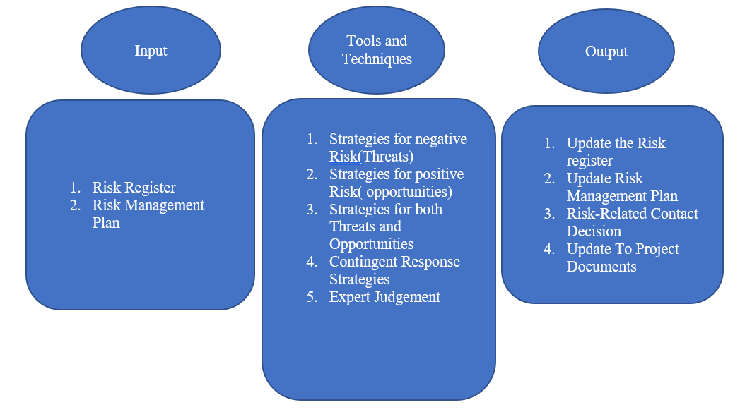

Risk Response

Negative Risk | Mitigate | Hotel Operation Team cannot clear out to three guestroom floors at 3 days as Project Team required
 | Accept | The material obtained by the supplier plier was not matching with the ordered material and the material sent by the supplier was also did not meet our quality standards.
Positive Risk | Enhance | An older generation of the in-room assistant (Alexa) being installed.

2.5 Risk Response implementation
Risk 1:
- Make a notice online and offline, on the website, over the phone, or when they visit a hotel that the hotel guestrooms will be refurbished from July 27 in 2022 to September 4 in 2023, causing visitors to be inconvenienced when they try to reserve the rooms.
- For clients who need to change rooms, the hotel provides room upgrades or discount coupons via text messages or by sending a coupon code in the mail for room bookings, breakfast, and supper.
Risk 2:
- During the project's Project Execution Phase, the requested material will be cross verified by mobile or email to ensure that the item sent by the supplier matches what we bought. Project Manager is fully responsible for material supplies.
Risk 3:
- During the Research phase of the project for the in-room assistant, a Google Alert is set up on the hotel app or website to receive pricing changes and to discover promptly if there are any important advancements with the company's manufacturing. When it comes to placing the order during the Construction Phase of the project, this gadget takes advantage of this information.

2.6 Risk Monitoring And Reporting
Chance administration and control help with the following of imminent extended dangers and the upgrading of recently recognized risks. Hazard checking may be utilized to keep track of progressing activities in numerous company parts. It is not as it helps in identifying dangers and creating relief strategies. Still, it also helps create a technique for assessing conceivable outcomes, both great and adverse, and corporate advancement and extension plans.
On the other hand, risk detailing is the method of creating a formal chance report given to the organization's beat administration and extended partners. The impact and seriousness of the extent and organizational activities to manage the project's potential dangers are utilized to classify chance detailing.
In this report, we are talking about Risk profile, Impact, tolerance levels and Effective risk management.
The project manager supervises obtaining and delivering project requirements, as well as carrying out the project management strategy. As the project continues, the risk register will be monitored and updated. A risk management strategy and timetable will also be utilized to detect, validate, and categorize any additional risks introduced over the course of the project. If any deviations from the established requirements are detected in the project, a change management strategy and forms will be employed, and project stakeholders will be engaged. Changes in strategy and method will be implemented only once sponsors and stakeholders have given their approval.
Probability of Occurrence
Very Unlikely | 1
Somewhat unlikely | 3
50-50 possibility | 5
Somewhat likely | 7
Very likely | 9

Impact of Risk |  | Costs | Schedule | Scope | Quality
Very Low | 1 | 10 - 50k | 0 - 5 | Scope impact barely discernable | Minor defects in production
Somewhat Low | 2 | 51-150k | 6 to 16 | Minor areas of scope impaired | Small number of moderate defects in prod
Moderate | 4 | 151-250k | 17 to 20 | Many minor areas of scope impaired | Moderate number of moderate defects in prod
Somewhat High | 6 | 251-350k | 21 to 28 | Major areas of scope impaired | High number of moderate defects in prod
High | 8 | 351-499k | 29 to 41 | Scope reduction unacceptable | Major defects in prod
Extremely High | 9 | 500K+ | 42 days+ | Final product undeliverable or useless | The final product is inoperable

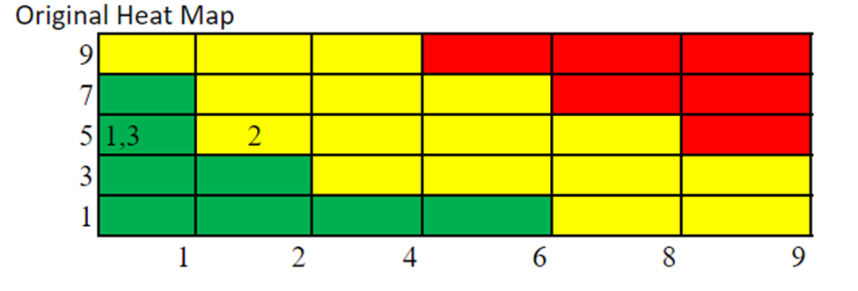

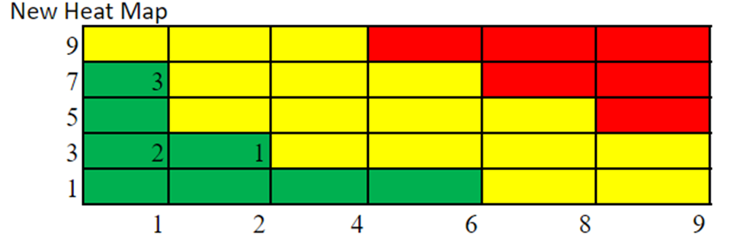

l X I = RS
Thresholds
High - 43-81
Medium - 8-42
Low - 1-7

3. Roles and responsibilities
RACI Chart
R=Responsible A=Accountable C=Consulted I=informed S=Support
Task | Project Manager | Project team | Sponsor | Key stakeholders
Project charter | R/A | R | I | I
Initiate RMP | R | S | A | A
Risk identification | R | I | A/I | I
Risk Prioritization | R | I | S | I
Budget Planning | A | R | I/C | I/C
Map out Impact V/S Likelihood | S | R | - | I
Identify Triggers | R | S | - | -
Risk response planning | R | S | I | -
Risk response implementation | R/S | R | - | C
Report risk status | S | R | A | I
Monitoring and control | S | R | - | -
Review and revision of RMP | R | I | I | I

Budgeting
Budget | Range | Work
Overall budget | $5,000,000 | Overall budget allocated for cosmetic refurbishment of Embassy Suites DFW Airport North Refurbishment Project
Project Initiation | $2,000 | Cost used for kick-off the project and start project timeline
Project Documentation | $52,000 | Cost assigned to prepare documents for different tasks like permits, insurance, design drawings
Research | $11,200 | Design research and current location research will be carried out using this assigned cost
Design | $14,400 | All the 3 designs will be carried out using the cost allocated and final design will be decided
Renovation | $4,764,000 | Materials of refurbishment of Guest rooms, lobby and meeting space will be ordered using the cost decided after carrying out the research
Sign-off | $4,000 | Cost mentioned will be used to attain the sponsors approval and to close the project
Contingency Reserve | $500,000 | A contingency reserve of ten percent of the budget is set aside to mitigate risks.

- The project consists of 3 risks containing 2 negative and 1 positive risks. 2 risks are in low threshold and 1 in moderate before implementation of preventive risks.
- Cost used by 2 preventive risk will be used from contingency reserve and the amount used by them are:
Risk 1: $7,500
Risk 2: $10,000

Risk 3 is the positive risk and instead of using it is saving the cost from contingency reserve. Risk 3: $17,000

Risks should be informed to change management board as soon as the risks are identified so that preventive measures can be implemented, and cost should be paid off as soon as we attain sponsor’s approval.

Timing
- Every 15% of finished work or every two months, whichever comes first, the risk management approach should be evaluated and improved, and the risk register should be updated biweekly.
- A consistent plan for assessing risk reduction methods should be developed, as well as an improved execution strategy. Quarterly risk reports, status updates, and progress reports should be delivered.
- Risk response plan should be reviewed bi-weekly during project timeline to have constant follow-up on the risks and closing of the risks can be done before risk is converted into issue.
- The timings to review the risks and updates on it will be determined based on the response obtained by change management board and sponsors so that latest updates can be implemented and reviewed as soon as possible.

Risk Breakdown structure/ categories
There are four categories of risks that we considered for the Embassy Suites DFW Airport North Refurbishment Project (Bishop, 2021):
- Technical Risks: issues that deal with the technical prowess and expertise of the team with relation to the project
  - General Contractor may not have the expertise to manage a job of this scope and magnitude with 330 guestrooms, lobby and meeting space to redo.
- Project Management Risks: details risks that have to do with the project team and its efficiency and teamwork
  - Risks of interpersonal issues between different members of the project team (for example, between the designer and the guestroom construction team)
- Organizational Risks: encompasses risks that have to do with the general organizational culture
  - Risks of not receiving approvals in a timely fashion due to bureaucratic delays
- External Risks: comprised of risks that can impact a project but are external to both the organization and that which you can control directly
  - Permitting from the city of Grapevine, TX
  - Supply Chain Issues with Materials for any of the spaces being refurbished

stakeholder risk tolerances
Stakeholder risk tolerances are evaluated from three aspects which are business motivation, performance evaluation, and culture of the organization.
The stakeholders have their business motivations to protect cost, time, or scope. In our case, the Guestroom, Lobby, Meeting Space 3 Construction Teams, and Hotel Management Team more focus on time constraints as there will be two big holidays – Christmas and New Year at the end of 2023 when construction team members want to accompany their families and Atrium hotel expects an increase in business revenue and market share through providing a better customer experience with the renovated hotel environment. Sponsors and the Finance Team have some concerns about cost constraints due to the limited budget. The rest of the stakeholders such as Compset Researcher, Local Research, and Designers care more about scope constraints as renovation details are expected to be customer-centric and trendy but must be within the agreed-upon project scope.
Moreover, to know how stakeholders will evaluate project performance, we had an in-depth interaction to know construction teams, and the operation team were mildly excited about the completion of hotel renovation in November 2023, Finance team expressed overbudget was not their biggest concern because Sponsors were interested in fashionable renovation style, and the rest stakeholders believed the deliverables would be within the current scope.
Lastly, referring to Atrium Hotel’s culture, it is in the hospitality industry. In the past 3 years, the whole industry has grown with a conservative business approach. However, Atrium’s top management team wants to look for some breakthrough opportunities even if they are unsure about the future, especially during the period of the Covid pandemic.
Most key stakeholders' tolerance to risk is close to medium, which means low and medium-level risks will be accepted by Atrium’s stakeholders. They are willing to accept a maximum 40% risk.

Communication: reporting formats
Based on the project's priority, the impact of assigned tasks, and important deliverables, any hazards detected in the project must be reported to project colleagues, sponsors, and stakeholders.
Purpose | Description | Frequency | Communication Tool
Risk Identification | Brainstorming of the positive risks and negative risks which can occur in the project timeline | Weekly  On Wednesday of every week | Virtual Meetings
Risk Analysis | Analysis of risks using the formula of likelihood * Impact = Risk Score and obtain the threshold of the risk and implementation on heat map | Weekly  On Thursday of every week. | Virtual Meetings
Risk Prioritization | Prioritization of the top risk using the heat map | Bi-weekly  On Fridays of every week | Virtual Meetings
Risk Action | Decision would be made on the risk whether to mitigate or transfer the risk. Preventive measures would be implemented on that risk after obtaining approval from change management board and sponsors. | As soon as top risks are decided.  Monday of the next week of risk prioritization. | Virtual Meetings
Risk Monitoring and Controlling | Continuous monitoring on the risks will be performed so that status can be updated, and sponsors can be informed regarding the status of the risks. Controlling of the risks will be performed just to ensure that any are risks are not being created. | Monthly  On every first Monday of the month | Virtual meetings
Risks Closing | Closing of the risks will be obtained as soon as the risk affecting task are performed. | Within 1 week of risk affecting task completion | Virtual Meetings
Lessons Learned | Sponsors and Project team will discuss regarding the strategies they have used to mitigate the risks. | Week after risk is declared closed | Virtual Meetings

Change management Process used during obtaining approval from change management board and sponsor:
- Change Template with recommended changes is submitted for approval to change management board.
- Change board analyses these changes and will decide whether to accept, reject, or defer the change basis their analysis as to what impact these changes may cause to the overall project.
- If accepted, these changes are then sent to the sponsor for funding of these accepted changes. In case rejected, risks are accepted.
- Sponsor again has the authority to accept or reject these changes. If accepted, sponsor can provide funding from either of the management or contingency reserves. If rejected, then risks are accepted.

Risk management plan approval
The undersigned acknowledge they have reviewed the Risk Management Plan for the Embassy Suites DFW Airport North Refurbishment project. Changes to this Risk Management Plan will be coordinated with and approved by the undersigned or their designated representatives.
Signature: | Elizabeth Cohn | Date: | 05/16/2022
Print Name: | Elizabeth Cohn
Title:
Role: | Supporter

Signature: | Ruisi Meng | Date: | 05/16/2022
Print Name: | Ruisi Meng
Title:
Role: | Supporter

Signature: | Aastha Lalit Motwani | Date: | 05/16/2022
Print Name: | Aastha Motwani
Title:
Role: | Recorder

Signature: | Qingyu Sha | Date: | 05/16/2022
Print Name: | Qingyu Sha
Title:
Role: | Facilitator

Signature: | Mophy Sharma | Date: | 05/16/2022
Print Name: | Mophy Sharma
Title:
Role: | Project Manager
APPENDIX A: REFERENCES
The following table summarizes the documents referenced in this document.
Document Name and Version | Description | Location
Embassy Suites DFW Airport North Refurbishment Project Version 1.0 | Background information about Atrium Hospitality | https://atriumhospitality.com/our-story/
Embassy Suites DFW Airport North Refurbishment Project Version 1.1 | Risk Categories | https://www.fool.com/the-blueprint/risk-categories/
Risk Register and Critical Risk Sheets | Risk Management Documentation | Page 24-26

